## Module 1 Digital Transformation with Cloud Computing

#### Topic 1: The New Digital Age

**Introduction**

In this topic, we will In this topic, we'll explore what digital transformation is, the key transformation drivers, and the technologies at the forefront of enterprise digital transformation.

Throughout this topic, we will attempt to answer the following questions:

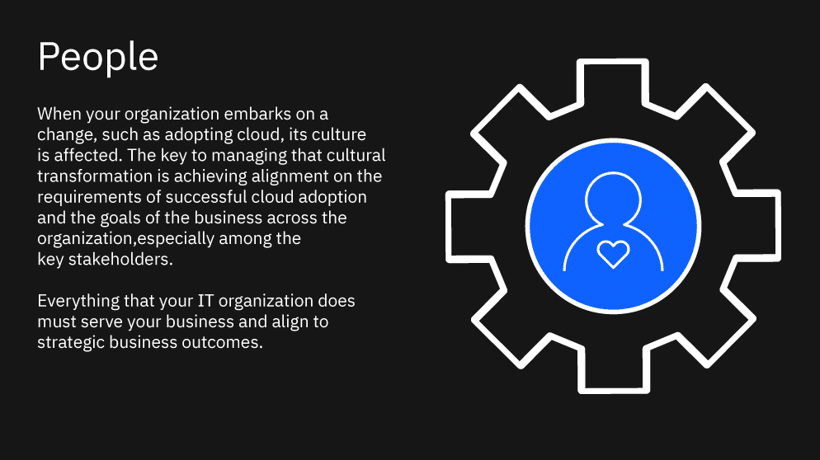

**1 . How have industries benefitted from adopting digital transformation practices?**

We are at one of the tipping points in history where the impact of technology on business is significant enough to transform the whole way that business gets done.

The New Digital Age

It’s no secret that the pace of innovation and change has accelerated rapidly over the last few years. From the explosion of social media to online shopping and apps to track your driver, digital transformation has quickly become an integral part of daily life.

What is Digital Transformation?

Collage of transformation drivers like using mobile devices, social media, IoT devices, Cloud services

Digital transformation takes a customer-driven, digital-first approach to all aspects of a business, from its business models to customer experiences to processes and operations. It uses AI, automation, hybrid cloud, and other digital technologies to leverage data and drive intelligent workflows, faster and smarter decision-making, and real-time response to market disruptions. And ultimately, it changes customer expectations and creates new business opportunities.

While many organizations have undertaken a digital transformation in response to a single competitive threat or market shift, it has never been about making a one-time fix. According to MIT Sloan Management Review, "Digital Transformation is better thought of as continual adaptation to a constantly changing environment." Its goal is to build a technical and operational foundation, to evolve and respond in the best possible way to unpredictable and ever-changing customer expectations, market conditions, and local or global events.

Digital Transformation Drivers

Customer expectations have always been the prime drivers of digital transformation. It began when a rush of new technologies made new kinds of information and capabilities accessible in new ways, such as:

Mobile devices

Social media

The internet of things (IoT)

Cloud computing

Pioneers—disruptors—such as Amazon and Netflix snatched market share from their competition by adopting these technologies to:

Reinvent business models (e-commerce, electronic delivery).

Optimize processes (supply chain management, new feature development).

Constantly improve the customer experience (in-context customer reviews, personalized recommendations).

Competitors adapted to provide even more capability and convenience (or they struggled and maybe even disappeared).

Today, customers expect to conduct all business digitally, wherever, and whenever, using any device, with all the supporting information and content they need close at hand. Ultimately, digital transformation is about meeting these ever-escalating expectations. But often, an organization's entry point is a transformation initiative that addresses a specific means to this end, such as:

Automating business processes

Defending against disruption

Dealing with change effectively

Enabling on-demand access to more resources, with fewer limits

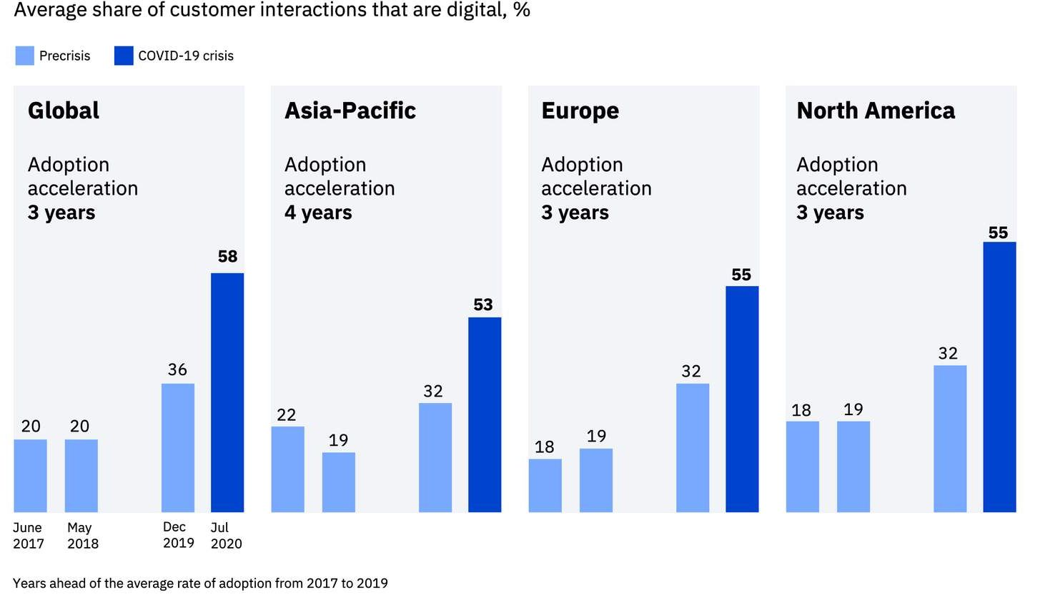

In 2020, the COVID-19 pandemic laid bare every organization's digital transformation efforts and progress (or lack thereof). Manufacturers learned just how quickly and effectively they could get new products to market. Retailers scrambled to provide customers with new and safer ways to shop. Employers adopted or expanded technologies that let employees work from home.

Among operational workflows, supply chains were the most glaringly exposed. Supply chains are always vulnerable; according to the McKinsey Global Institute, supply chain disruptions lasting one month or longer occur every 3.7 years. But shortly after the pandemic began, the United States suddenly imported almost 50% less from major trading partners. Companies were forced to undergo years or decades' worth of supply chain transformation in weeks or months.

The arrival of the pandemic forced us to reconsider the capabilities we had at our fingertips and adapt them to the circumstances we now face daily. Take video conferencing, for example. We’ve had this capability for years, but we never quite realized its full potential. Now, video calls are an essential part of our day, proving their worth far beyond hosting meetings remotely.

Patients can have a video consultation with their doctor and have their prescription made available at their closest pharmacy. It benefits the doctor, the patient, and everyone who may come into contact with the patient. This highlights the rapid acceleration of digital transformation out of necessity – but also how the right technology can enhance employee and customer safety.

**2 . What role have technologies such as AI, Cloud, and IoT played in the digital revolution?**

Enterprises will look back at the start of the 2020s as a moment when they either seized opportunities or naively hoped old ways of doing business would survive. Smarter businesses realize that it’s a critical time to meet people’s evolving needs and give their customers exceptional experiences. Business transformation is the key to accomplishing these goals, studies show.

As disruption and volatility may continue for the foreseeable future, the organizations that apply human-focused strategies Business transformation will determine who thrives in the new landscape ahead and the new capabilities of emerging and advancing technologies will be positioned to lead in the “new normal” to come.

Transformational Technologies

Virtually any digital technology can play a role in an organization's digital transformation strategy. But technologies that figure to play a central role today and in the near future include:

Digitization

Artificial intelligence and automation

Cloud Computing

Microservices

Internet of Things

Blockchain

Combining multiple technologies, including cloud, cognitive AI, mobile, and the Internet of Things (IoT), Digital Reinvention rethink customer and partner relationships from a need-, use- or aspiration-first perspective. Digital Reinvention helps organizations create unique, compelling experiences for their customers, partners, employees, and other stakeholders. These benefits arise regardless of whether enablement or fulfillment of the experience involves the direct provision of products or services or orchestration of products or services from partner organizations by way of a business ecosystem. The most successful digitally reinvented businesses establish a platform of engagement for their customers, acting as an enabler, conduit, and partner.

How Cloud Fits into the Bigger Picture

The ongoing digital revolution affects individuals and businesses alike. Increasingly, social networks and digital devices are the default means for engaging government, businesses, and civil society, as well as friends and family members. People use mobile, interactive tools to determine who to trust, where to go, and what to buy. This means that the last best experience that people have anywhere becomes the minimum expectation for the experience they want everywhere, including in the enterprise. Given the competitive landscape, this means that enterprises must undertake their own digital transformations, rethink what their customers value most, and create operating models that take advantage of what is newly possible for competitive differentiation. The challenge for the enterprise is how fast and how far to go down the path to digital transformation and cloud adoption.

Increasing customer expectations and a more competitive business context have placed tremendous pressure on business leaders to change the way they set their strategies and run their organizations. New requirements to incorporate more information and greater interactivity quickly drive up costs and complexity.

Futuristic digital background connecting different technologies to cloud.

Business leaders have long used information technology to improve productivity and efficiency, reach new markets, and optimize supply chains. What is new is that customer expectations have changed.

How can enterprises best respond to this shift?

How can they take advantage of the opportunity to innovate and grow through technology adoption?

How can they do all this cost-efficiently?

This is the domain of digital transformation and its intersection with cloud adoption. Digital transformation incorporates the change associated with the application of digital technology in all aspects of society. Cloud Adoption is the way in which businesses implement digital transformation.

In our work with clients, we have found that enterprises that can develop and effectively execute a digital transformation strategy and take full advantage of new technologies, such as cloud are able to transform their business models and set a new direction for entire industries.

We believe the most crucial decision that a company can make to successfully pursue a digital transformation strategy is to wholeheartedly yet thoughtfully adopt the cloud as the IT platform of choice. We have observed many companies that have successfully used cloud adoption to rapidly advance their digital transformation strategy. We have also seen companies make unsuccessful cloud adoption decisions that have hampered or set back their pace of digital transformation. What we will show you in this book is how to model your decision-making process after the successful transformations while avoiding the common pitfalls we’ve seen in the unsuccessful transformations.

How the hybrid cloud can create the world's computer

Digital Transformation in Action

Image showing a truck which is ready to ship goods representing Convoy App

Convoy looks to disrupt the USD $700billion trucking industry Convoy, a Seattle-based start-up, has developed an Uber-like app interface to give individual truckers a more efficient way to connect with individuals and businesses that want to ship goods.

By matching truck drivers with clients directly, Convoy disintermediates traditional brokers. The company and other entrants such as Los Angeles-based Cargomatic intend to reduce the average transportation prices and delivery times while increasing average loads and trucker income.

Lending Club challenges traditional banks in their backyard San Francisco-headquartered Lending Club offers better borrowing and lending rates than traditional banks.

Operating online, Lending Club automates peer-to-peer loans across its digital platform. With operating costs that are 60 percent lower than those of traditional banks, Lending Club has experienced massive growth over the past five years. Lending Club still has substantial space for growth in an area of the market that has historically produced more than 4 billion in profits annually.

Women sitting at home with the mobile/laptop ready to lend money from the Lending app

Image showing fields covered with solar panels producing clean energy.

Clean Energy Collective devises new modes of generation and consumption Founded in 2010, the Colorado-based Clean Energy Collective (CEC) builds, operates, and maintains community-based clean energy facilities.

Using remote metering technologies that integrate seamlessly with utility billing systems and installing solar panels either on customer’s property or elsewhere, CEC is able to track and apply for clean energy production credits directly on customer’s bills.

By the end of 2015, more than 27 gigawatts of solar capacity was online in the United States, enough to power more than 5.4 million homes.

Why it matters?

Since the rise of the internet in the late 1990s, companies under increasing pressure to stay ahead of the curve. Social media, big data, artificial intelligence, and cloud computing are just a few of the technologies at the forefront of the digital revolution. To remain competitive, organizations must continually adapt and innovate in order to meet customer expectations.

#### Topic 2: What is Cloud

**Introduction**

In this topic, we'll define cloud computing and discuss its capabilities and benefits in a business context.

Throughout this topic, we will attempt to answer the following questions:

**1. What is cloud computing?**

Cloud computing transforms IT infrastructure into a utility: It lets you ‘plug into' infrastructure via the internet, and use computing resources without installing and maintaining them on-premises.

What is Cloud Computing?

Digital transformation is the change associated with the application of digital technology in all aspects of society. Cloud adoption is the way in which businesses implement digital transformation.

Cloud presents many benefits, including greater agility, speed to market, and improved efficiency. Cloud can open the door to enhanced user experiences and new markets. But only a small percentage of workloads have made it to the cloud. Why? Because the remaining core business workloads are harder to move, share dependencies, and require a more thoughtful and holistic approach.

You need to transform to keep up with the pace of modern environments, considering factors such as dynamic market conditions, speed of technology, faster and leaner competition, and ubiquitous innovation. And the starting point needs to meet you where you are on your journey.

Image showing a person with applications in the cloud, business connected.

Cloud computing, sometimes referred to simply as “the cloud,” is the use of computing resources — servers, database management, data storage, networking, software applications, and special capabilities such as blockchain and artificial intelligence (AI) — over the internet, as opposed to owning and operating those resources yourself, on-premises.

Compared to traditional IT, cloud computing offers organizations a host of benefits: the cost-effectiveness of paying for only the resources you use; faster time to market for mission-critical applications and services; the ability to scale easily, affordably and — with the right cloud provider — globally; and much more (see “What are the benefits of cloud computing?” below). And many organizations are seeing additional benefits from combining public cloud services purchased from a cloud services provider with private cloud infrastructure they operate themselves to deliver sensitive applications or data to customers, partners and employees.

Increasingly, “cloud computing” is becoming synonymous with “computing.” For example, in a 2019 survey of nearly 800 companies, 94% were using some form of cloud computing. Many businesses are still in the first stages of their cloud journey, having migrated or deployed about 20% of their applications to the cloud, and are working out the unique security, compliance, and geographic implications of moving their remaining mission-critical applications. But move they will: Industry analyst Gartner predicts that more than half of companies using cloud today will move to an all-cloud infrastructure by next year (2021).

Watch our expert summarize this topic (you can use the picture-in-picture option and scroll down)

**2. What are the key capabilities of cloud computing?**

Thanks to its speed, scale, and capacity, the cloud offers more functionality with more automation than nearly every on-premises solution.

Cloud Capabilities :

Cloud is built around services

Cloud is automated

Cloud (usually) oversees your networking

Image showing a person using mobile to book cab successfully.

If the Cloud was a Rental Car

1) Rental cars are available when and where you need them.

When we fly somewhere to go on vacation, we usually rent a car. It is very easy to do, and in most areas in the United States, you need a car in order to get around. When we go skiing in Colorado, we rent a car. When we go to Michigan in the summer, we rent a different one. It doesn’t matter if the cars are provided by different rental car companies; they serve the same purpose and are designed to do the same thing. Very similar to cloud computing, we can access the computing resources we need when and where we need them.

2) When you rent a car, you pay only for the time you use it.

When we travel to these various cities, obviously it doesn’t make sense to buy a car in each one of them. We don’t need a car all the time, so we don’t want to own it all the time. When we have these temporary needs, we rent a car for the location and time that we need it, without being required to buy and maintain it permanently. In a typical cloud computing environment, it works the same way; companies pay only for what they actually use. Instead of saving the cost of buying and maintaining a car, they are saving the money required to buy large computers.

3) Booking a rental car is easy to do by yourself.

Before we go on a trip, we never actually call and talk to a person at the rental car company to reserve a rental car. All of the rental car companies have websites designed for you to enter the type of car you need, where you want to pick it up, and for what time period you want to use the car. This same self-service method is used for cloud computing. Companies can log into websites to request the specific computer resources that they need.

4) The rental car company has a large number of vehicles that it can rent, and can buy more cars to rent if there are consistently many requests.

Car rental companies have many types of cars that they rent out, but effectively, the cars all serve the same purpose: they get you from point A to point B. However, there is a difference between a compact car and a luxury SUV. To account for this, rental car companies have the flexibility to offer various prices for various car sizes. They also have the ability to provide a higher class car than reserved. This allows them to have a smaller total number of cars than what would be needed if they had to keep a specific number of each class of cars. This practice is like grouping a large number of computers together to form a cloud. The computers might be different models or have different sizes of hardware, but when you group them all together into a resource pool, you ensure you have enough power to go around.

5) You can rent a different type of car for different situations.

When you go to the beach, you rent a convertible. When you go skiing, you rent something with an all-wheel drive and a ski rack. When you are driving a long distance, you select something that gets good gas mileage. Each one of these vehicles would likely have a different cost associated with them. Similarly, in cloud computing, you can select different cloud services to fit your various needs. You could select a cloud service with a lot of resources behind it for a very processing-intensive need task, or you could select a cheaper cloud service if you need fewer resources. In cloud terminology, this is sometimes referred to as being “Fit for Purpose.”

6) You aren’t responsible for maintaining a rental car.

Oil changes, tire rotations, and changing the spark plugs are all things that you don’t have to worry about when you are renting a car. The rental car company handles all of these maintenance issues so you don’t have to. Realistically, this is built into the price of renting the car, but for the renter, it is worth it to have that peace of mind. Just as rental car providers maintain their fleet, cloud providers maintain the hardware and software running the cloud platform, so that the cloud consumers don’t need to worry about it.

7) If your rental car breaks down or you have an accident, the rental car company will bring you a new car.

They would also take care of driving or towing the original car away. Something similar happens in a cloud environment. If something happens to your cloud instance, the cloud provider can very quickly and easily create a new instance for you. This ability to quickly stand up to new services after a problem is referred to as disaster recovery.

8) If you are traveling with a big group you can rent multiple cars.

Sometimes my wife and I go on vacation with a group of friends. Between all the people and luggage, there isn’t enough room in one car (even a big one). Fortunately, rental car companies have many cars available to rent, and when we have this increased demand, we can rent multiple cars. In cloud computing, this is referred to as elasticity. When we need additional resources (or cars) we can rent them. When we no longer need the additional space, we can return the car to the provider and no longer need to pay for it.

Why it matters?

Cloud computing offers many advantages over traditional, "On-prem" IT architecture. With cloud, an organization has access to centralized servers and software without the need for a complex IT staff to program, secure, and maintain it. Cloud is also automated, providing you with access to its services on-demand. This allows organizations to scale up or down quickly as their business needs fluctuate.

#### Topic 3: Benefits of Cloud Computing

**Introduction**

In this topic, we'll take a look at the six key benefits of cloud adoption as an operational model.

Throughout this topic, we will attempt to answer the following questions:

**How do organizations benefit from adopting cloud as an operating model?**

After you complete the up-front tasks of translating a business problem into an AI and data science solution and understanding the data needs in support of your business problem, it’s time to prepare the data.

Tapping the power of cloud

The world is experiencing a digital and mobile transformation, with more information available more quickly in more mediums than ever before. As part of this, consumers have jumped on the social media bandwagon, with many relying on it as their primary collaboration format.

Image showing people working on the things done with cloud technology

Add to this the advent of new analytics capabilities and the results are sweeping changes in almost every aspect of daily business and consumer life. But how does cloud play into all of this?

Cloud provides a way for businesses to harness the capabilities borne of these digital trends to better meet customers’ needs and drive future growth. In fact, IBM research illuminated six key cloud attributes being used to power business model innovation, which we’ve dubbed business enablers:

* Cost flexibility
* Business scalability
* Market adaptability
* Masked complexity
* Context-driven variability
* Ecosystem connectivity

Cloud Business Enablers :

1. COST FLEXIBILITY

Cost flexibility is a key reason many companies consider cloud adoption in the first place. More than 31 percent of executives surveyed cited cloud’s ability to reduce fixed IT costs and shift to a more variable “pay as you go” cost structure as a top benefit. Cloud can help an organization reduce fixed IT costs by enabling a shift from capital expenses to operational expenses. IT capital expenses – which typically include enterprise software licenses, servers, and networking equipment – tend to be less fluid, more expensive, and harder to forecast than routine IT operating expenses. With cloud applications, there is no longer a need to build hardware, install software or pay dedicated software license fees. By adopting cloud services, an organization can shift costs from capital to operational – or from fixed to variable. The organization pays for what it needs when it needs it.

This pay-per-use model provides greater flexibility and eliminates the need for significant capital expenditures. Cost flexibility is certainly an appealing cloud attribute for Etsy, an online marketplace for handmade goods. In addition to bringing buyers and sellers together, Etsy also provides recommendations for buyers. Using cloud-based capabilities, the company is able to cost-effectively analyze data from the approximately one billion monthly views of its Web site and use the information to create product recommendations. The cost flexibility afforded through cloud provides Etsy access to tools and computing power that might typically only be affordable for larger retailers.

1. BUSINESS SCALABILITY

IT scalability is recognized by many as a major benefit of cloud adoption. However, cloud offers more than just IT scalability – it allows an organization to easily scale its business operations as well. By allowing for rapid provisioning of resources without scale limitations, cloud enables a company to benefit from economies of scale without achieving large volumes on its own. Recognizing cloud’s ability to facilitate efficient growth and expanded options, approximately a third of our survey view business scalability as a top cloud benefit.

To demonstrate this concept in action, consider Netflix, an Internet subscription service for movies and TV shows. Because it streams many movies and shows on-demand, the company faces large surges of capacity at peak times. As Netflix began to outgrow its data center capabilities, the company made a decision to migrate its Web site and streaming service from a traditional data center implementation to a cloud environment. This move allowed the company to grow and expand its customer base without having to build and support a data center footprint to meet its growth requirements.

1. MASKED COMPLEXITY

In addition to business scalability and market adaptability, cloud also offers the advantage of masking complexity. Cloud provides a way for organizations to “hide” some of the intricacies of their operations from end-users, which can help attract a broader range of consumers. Because complexity is veiled from the end-user, a company can expand its product and service sophistication without also increasing the level of user knowledge necessary to utilize or maintain the product or service. For example, upgrades and maintenance can be done in the “background” without the end-user having to participate.

Masked complexity is perhaps less recognized than some of the other enablers, as 20 percent of the business leaders in our survey cited it as a top benefit. Xerox definitely recognizes this cloud attribute, however, as evidenced by its Xerox Cloud Print solution. With Xerox Cloud Print, workers can get their desired content in printed form wherever they might be by using Xerox’s cloud to access printers outside their own organization. While printing from the cloud requires quite a bit of data management – with numerous files to be stored, converted to print-ready format, and distributed to printers – the complexity is hidden from users.

1. CONTEXT-DRIVEN VARIABILITY

Because of its expanded computing power and capacity, cloud can store information about user preferences, which can enable product or service customization. The context-driven variability provided via cloud allows businesses to offer users personal experiences that adapt to subtle changes in user-defined context, allowing for a more user-centric experience. This is a significant cloud attribute, as evidenced by the more than 50 percent of respondents who cited “addressing fragmented user preferences” as important for their organizations.

Siri, the Apple iPhone cloud-based natural language “intelligent assistant,” is all about context-driven variability. It allows users to send messages, schedule meetings, place phone calls, find restaurants, and more. And while other phones have some voice recognition features, Siri “learns your voice” as Wall Street Journal columnist Walt Mossberg put it. Siri uses artificial intelligence and a growing base of knowledge about the user, including his or her location and frequent contacts, to understand not only what is said but what is meant. In a nutshell, it leverages the computing capabilities and capacity of cloud to enable individualized, context-relevant customer experiences.

1. MARKET ADAPTABILITY

In today’s economic environment, the ability to respond to rapidly changing customer needs is a key competitive differentiator. As such, companies continuously seek ways to improve their agility to adjust to market demands. A third of the executives we surveyed believe cloud can assist in this respect, citing market adaptability among cloud’s top benefits. By enabling businesses to rapidly adjust processes, products, and services to meet the changing needs of the market, cloud in turn facilitates rapid prototyping and innovation and helps speed time to market.

The power of cloud ActiveVideo certainly recognized cloud’s power to enhance market adaptability when it created CloudTV, a cloud-based platform that unifies all forms of content – Web, television, mobile, social, video-on-demand, etc. – onto any video screen. Content and applications from Web content creators, television networks, advertisers, set-top, and other media entities can be developed quickly for CloudTV using standard Web tools. CloudTV leverages content stored and processed in the network cloud to significantly expand the reach and availability of Web-based user experiences, as well as to allow operators to quickly deploy a consistent user interface across diverse set-top boxes and connected devices. The CloudTV approach of placing the intelligence in the network, rather than the device, enables content creators, service providers, and consumer electronics manufacturers to create new television experiences for their viewers.

1. ECOSYSTEM CONNECTIVITY

Another business enabler powered by cloud is ecosystem connectivity, which is recognized by a third of our respondents as a major benefit. Cloud facilitates external collaboration with partners and customers, which can lead to improvements in productivity and increased innovation. Cloud-based platforms can bring together disparate groups of people who can collaborate and share resources, information and processes.

HealthHiway is a great example of how cloud can enable ecosystem connectivity. A cloud-based health information network, HealthHiway enables the exchange of information and transactions among healthcare providers, employers, payers, practitioners, third-party administrators, and patients in India. By connecting more than 1,100 hospitals and 10,000 doctors, the company’s software-as-a-service solution facilitates better collaboration and information sharing, helping deliver improved care at a low cost, particularly important in growing markets, such as India.

Why it matters?

Cloud computing provides numerous benefits for subscribers. Because cloud services are often purchased 'on-demand', businesses can easily scale up or down. This flexibility allows businesses to free up time and resources that would otherwise be dedicated to maintaining their own servers and software.

Cloud is everywhere. This means more connections to other services and customers, allowing organizations easier access to data in order to offer a more cohesive user-driven experience. Another benefit of the ubiquitous nature of cloud is that team collaboration can more easily be facilitated through cloud-based software than on-prem.

#### Topic 4: Cloud Delivery Models

**Introduction**

In this topic, we'll identify the main cloud delivery models and explore some key considerations when choosing a CDM.

Throughout this topic, we will attempt to answer the following questions:

**1 . What defines Traditional IT Architecture and what are the pros and cons of continuing to keep operations on-premise?**

Within the next three years, 75 percent of existing non-cloud apps will move to the cloud. Today’s computing landscape shows companies not only adopting cloud but using more than one cloud environment. Even then, the cloud journey for many has only just begun, moving beyond low-end infrastructure as a service to establish higher business value.

Choosing a Cloud Deployment Model

Cloud computing represents a massive paradigm shift in the way IT resources are created, delivered, and consumed. Cloud computing technology also serves as a core foundational driver of growth and innovation across the global IT landscape. However, the cloud computing solution space can indeed be confusing with a lot of new terms and technologies. Even organizations that have been using the Internet and cloud computing for basic tasks like mobile email, can go a little deeper and take a broader view of cloud computing.

Image showing a person thinking before making a choice.

Enterprises that are eager to undergo digital transformations and modernize their applications are quick to see the value of adopting a cloud computing platform. They are increasingly finding business agility or cost savings by renting software. Each cloud computing service and deployment model type provides you with different levels of control, flexibility, and management. Therefore, it’s important to understand the differences between them.

The right model depends on your workload and budget. You should understand the advantages and disadvantages of each cloud deployment model and take a methodical approach to determine which workloads to move to which type of cloud for the maximum benefit.

Traditional infrastructure

Before we dive into cloud, it's important to understand the foundations upon which cloud arose. Prior to cloud computing, companies stored their data, software, and operations on-premise, using their own IT servers. This increasingly outdated model is called Traditional Infrastructure, and sometimes referred to as 'legacy' or 'heritage' IT architecture.

Two people in Data Center while walking next to server Racks

A traditional IT infrastructure is made up of the usual hardware and software components: facilities, data centers, servers, networking hardware desktop computers, and enterprise application software solutions. Typically, this infrastructure setup requires more power, physical space, and money than other infrastructure types. Traditional infrastructure is typically installed on-premises for company-only, or private, use.

Organizations can have compelling reasons for keeping a legacy system, such as the system works satisfactorily and the owner sees no reason to change it, or certain data is seen as being too sensitive to store on a public cloud environment. Often the cost is one of the biggest concerns for companies unsure of whether to migrate some or all of their operations to the cloud. The costs of redesigning or replacing the system are prohibitive because it is large, monolithic, and/or complex. Retraining on a new system would be costly in lost time and money, compared to the anticipated appreciable benefits of replacing it (which may be zero).

Even if it is no longer used, a legacy system may continue to impact the organization due to its historical role. Historic data may not have been converted into the new system format and may exist within the new system with the use of a customized schema crosswalk, or may exist only in a data warehouse. In either case, the effect on business intelligence and operational reporting can be significant. A legacy system may include procedures or terminology which are no longer relevant in the current context and may hinder or confuse understanding of the methods or technologies used.

**2 . What differentiates Public and Private delivery models?**

**Public Cloud**

A public cloud is perhaps the simplest of all cloud deployments: A client needing more resources, platforms, or services simply pays a public cloud provider by the hour or byte to have access to what’s needed when it’s needed. Infrastructure, raw processing power, storage, or cloud-based applications are virtualized from hardware owned by the vendor, pooled into data lakes, orchestrated by management and automation software, and transmitted across the internet—or through a dedicated network connection—to the client.

Public cloud architectures are multi-tenant environments—users share a pool of virtual resources that are automatically provisioned for and allocated to individual tenants through a self-service interface. This means that multiple tenants’ workloads might be running CPU instances running on a shared physical server at the same time. Each cloud tenant’s data is logically isolated from that of other tenants, however.

Think about it like this. Cloud computing is the result of a meticulously developed infrastructure, kind of like today’s electric, water, and gas utilities are the result of years of infrastructural development. Cloud computing is made available through network connections in the same way that utilities have been made available through networks of underground pipes.

Homeowners and tenants don’t necessarily own the water the comes from their pipes; don’t oversee operations at the plant generating the electricity that powers their appliances, and don’t determine how the gas that heats their home is acquired. These homeowners and tenants simply make an agreement, use the resources, and pay for what’s used within a certain amount of time.

Public cloud computing is very similar. The clients don’t own the gigabytes of storage of the data they use; don’t manage operations at the server farm where the hardware lives; and don’t determine how their cloud-based platforms, applications, or services are secured or maintained. Public cloud users simply make an agreement, use the resources, and pay for what’s used.

**Private Cloud**

Private cloud is a single-tenant (one user) cloud infrastructure operated exclusively for one company; it’s managed by the company or a third party (or both) and is hosted primarily on-premises, but can also be hosted on dedicated cloud-provider or third-party infrastructure. Private cloud enables a company to take advantage of cloud efficiencies while providing greater control over resources, governance, data security and regulatory compliance, and avoiding the potential impact of sharing resources with another cloud customer.

Many companies choose private cloud over public cloud because private cloud is an easier way (or the only way) to meet their regulatory compliance requirements. Others choose private cloud because their workloads deal with confidential documents, intellectual property, personally identifiable information (PII), medical records, financial data, or other sensitive data.

Private cloud typically involves higher up-front and ongoing costs than public cloud. But emerging public cloud offerings such as virtual private clouds (VPCs) bring many of the same benefits as private cloud computing without imposing the same cost or management burdens. And new private cloud offerings such as managed private cloud services—in which a third-party vendor steps in to deploy, configure, and manage the private cloud on the customer’s behalf—are also making private cloud-like services easier to consume.

By building private cloud architecture according to cloud-native principles, an organization gives itself the flexibility to easily move workloads to public cloud or run them within a hybrid cloud (mixed public and private cloud) environment whenever they’re ready.

Building a private cloud makes it possible for all enterprises—even those in highly regulated industries—to avail themselves of many of the benefits of cloud computing without sacrificing security, control, and customization.

**In general**, public cloud is a better choice if the following are true:

Scalability and elasticity—the ability to add capacity instantly or automatically in response to unexpected surges in traffic—are important to you.

You’d like to avoid upfront capital expenses and prefer more predictable ongoing operating expenses.

You want unlimited access to particular resources that are available through a public cloud provider.

However, if you have highly specialized security, regulatory, or infrastructure needs, want maximum control over your cloud environment, and find that your workloads have predictable usage patterns, a private cloud or private cloud-like service could better a good fit.

**3 . How does Hybrid Cloud solve many of the problems posed by Public and Private cloud deployment models?**

Hybrid cloud integrates private and public clouds, using technologies and management tools that allow workloads to move seamlessly between both as needed for optimal performance, security, compliance, and cost-effectiveness.

For example, hybrid cloud enables a company to keep sensitive data and mission-critical legacy applications (which can’t easily be migrated to the cloud) on-premises, while leveraging public cloud for SaaS applications, PaaS for rapid deployment of new applications, and IaaS for additional storage or compute capacity on demand.

Hybrid Cloud

Image showing structure of hybrid cloud which allows to combine cloud applications and data.

Today’s hybrid clouds are architected differently. Instead of connecting the environments themselves, modern IT teams build hybrid clouds by focusing on the portability of the apps that run in the environments.

Think about it like this: Instead of building a local two-lane road (fixed middleware instances) to connect two interstate highways (a public cloud and a private cloud), you could instead focus on creating an all-purpose vehicle that can drive, fly, and float. Either strategy still gets you from one place to another, but there's a lot less permitting, construction, permanency, and ecological impact if you focus on a universally capable vehicle.

Modern IT teams build hybrid clouds by focusing on the car—the app. They develop and deploy apps as collections of small, independent, and loosely coupled services. By running the same operating system in every IT environment and managing everything through a unified platform, the app's universality is extended to the environments below it.

**4 . What considerations need to be made (in terms of security, storage, and pricing) before choosing a cloud service model?**

Things to Consider When Choosing a CDM

Cloud Computing - Storage

Cloud Computing - Pricing

Security Issues in Cloud Computing

10 Tips for Choosing the Right Cloud Delivery Model

* Do your homework. Don’t assume that the provider that’s currently in the news with price decreases will be the best-priced provider for your workload.
* Understand all workload requirements that will impact cloud workload costs and operations (not just compute and storage). Consider costs associated with licensing software for each core, data transfer to the internet or private network, and persistent storage.
* Understand how the provider will support geographically-dispersed workloads. If your application must move data throughout the globe, ensure that the provider not only has data centers in the regions where you do business, but also a high-performance, private global network. Also consider whether the provider charges data transfer fees between and among cloud centers — any such fees can considerably add to costs if your company expands globally.
* Consider your business requirements, including the “agility” tradeoff. Can you afford to lock into a specific provider, unit type, volume or time frame, even if it means a discount?
* Consider the “net present value of money” when you evaluate long-term pricing options. Seek input from your finance department, especially if you are considering an upfront payment option. This will ensure your comparisons are valid and adhere to your company’s accounting rules for net present value.
* Factor in the non-workload-specific costs your business will need to run the workload optimally, including technical support, engineering, and even professional services.
* Allow for changing workload needs. You should be able to move workloads as needed from, for example, bare metal to virtualized servers without a major effort.
* Consider the big picture. Each cloud workload should fit into a holistic cloud strategy, one that will likely comprise multiple deployment models, geographies, and vendors.
* Even as you consider price performance based on the individual cloud workload, consider the provider’s ability to support your broader hybrid IT strategy via OpenStack-compatible platforms, integrated solutions, and seamless migration across models.
* Finally, don’t just look at the price for the workload. Instead, consider price-performance to be your base unit of comparison as you consider cloud options or any type of IT option.

Why it matters?   
One of the most important features of cloud computing is that it gives you the ability to customize a cloud solution to your business needs. Choosing a cloud delivery model, however, involves careful consideration of factors such as cost, speed, security, and maintaining compliance with government regulations.

#### Topic 5: Cloud Service Types

**Introduction**

In this topic, we'll explain and compare the three most popular cloud computing service models: IaaS, PaaS, & SaaS.

**1. What is Infrastructure as a Service (IaaS) and when would a company likely purchase this cloud service type?**

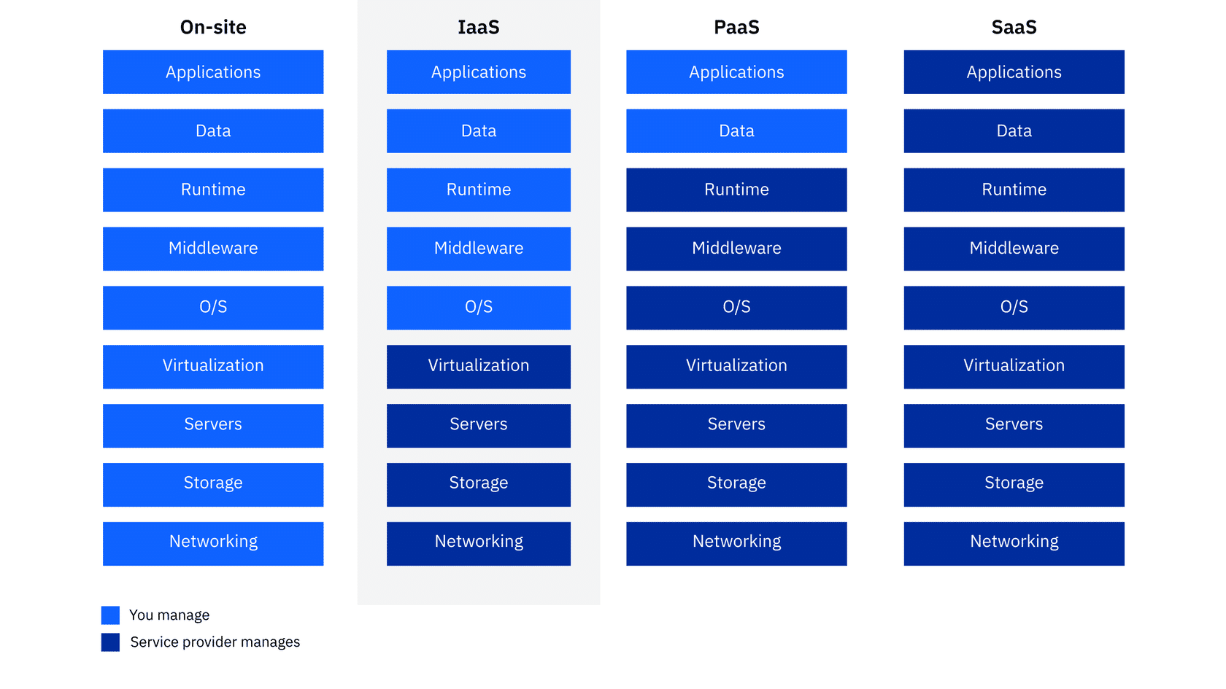

IaaS means a cloud service provider manages the infrastructure for you—the actual servers, network, virtualization, and data storage—through an internet connection. The user has access through an API or dashboard and essentially rents the infrastructure. The user manages things like the operating system, apps, and middleware (software that provides common services and capabilities to applications outside of what’s offered by the operating system) while the provider takes care of any hardware, networking, hard drives, data storage, and servers; and has the responsibility of taking care of outages, repairs, and hardware issues. This is the typical deployment model of cloud storage providers.

Typically, IaaS customers can choose between virtual machines (VMs) hosted on shared physical hardware (the cloud service provider manages virtualization) or bare metal servers on dedicated (unshared) physical hardware. Customers can provision, configure and operate the servers and infrastructure resources via a graphical dashboard, or programmatically through application programming interfaces (APIs).

IaaS can be thought of as the original 'as a service' offering: Every major cloud service provider - Amazon Web Services, Google Cloud, IBM Cloud, Microsoft Azure - began by offering some form of IaaS.

**Benefits of IaaS**

Compared to traditional IT, IaaS gives customers more flexibility to build out computing resources as needed and to scale them up or down in response to spikes or slowdowns in traffic. IaaS lets customers avoid the up-front expense and overhead of purchasing and maintaining its own on-premises data center. It also eliminates the constant trade-off between the waste of purchasing excess on-premises capacity to accommodate spikes, versus the poor performance or outages that can result from not having enough capacity for unanticipated traffic bursts or growth.

**2. What is Platform as a Service (PaaS) and when would a company likely purchase this cloud service type?**

PaaS means the hardware and an application-software platform are provided and managed by an outside cloud service provider, but the user handles the apps running on top of the platform and the data the app relies on.

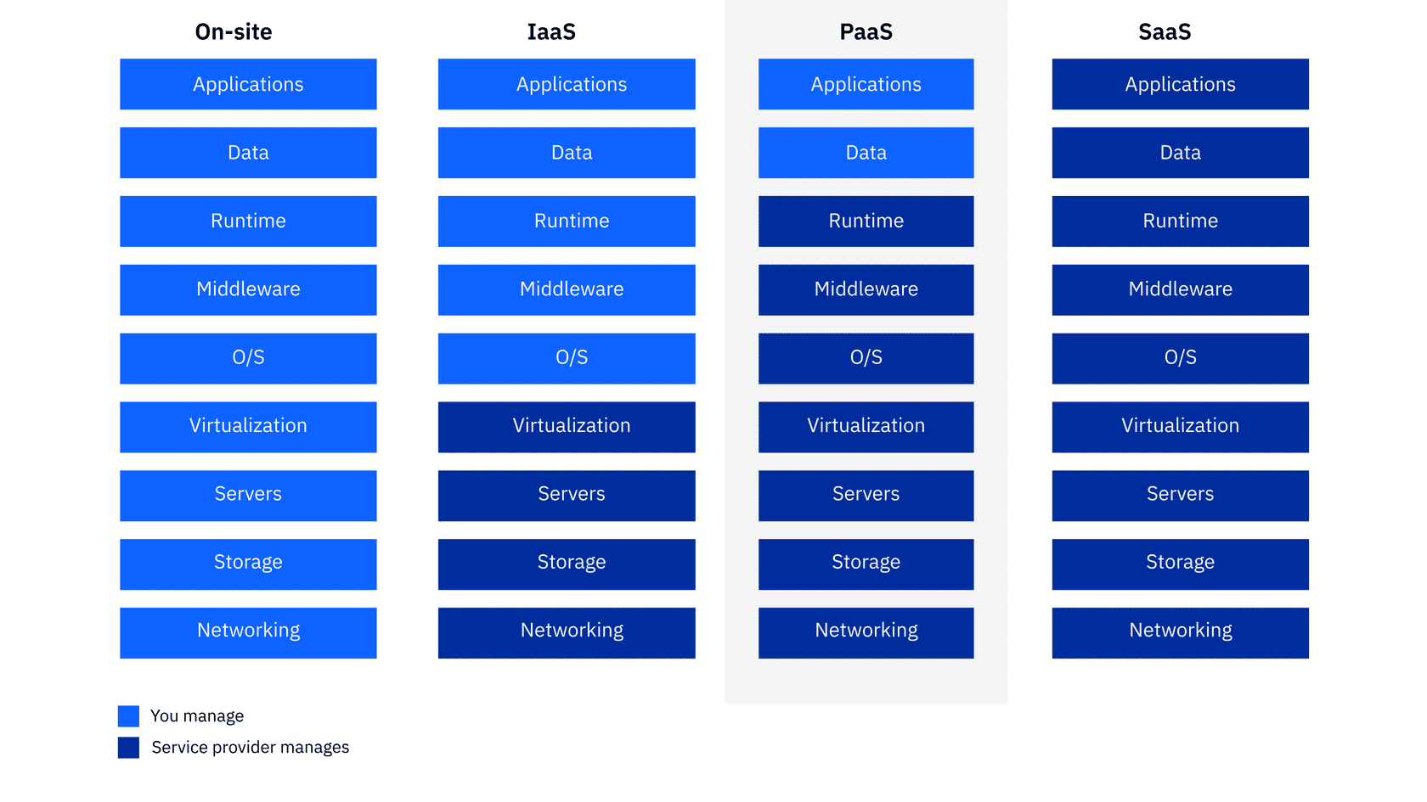

**Platform as a Service (PaaS)**

Primarily for developers and programmers, PaaS gives users a shared cloud platform for application development and management (an important DevOps component) without having to build and maintain the infrastructure usually associated with the process.

**Benefits of PaaS**

The primary benefit of PaaS is that it allows customers to build, test, deploy run, update, and scale applications more quickly and cost-effectively than they could if they had to build out and manage their own on-premises platform.

**3. What is Software as a Service (SaaS) and when would a company likely purchase this cloud service type?**

SaaS is a service that delivers a software application—which the cloud service provider manages—to its users. Typically, SaaS apps are web applications or mobile apps that users can access via a web browser.

**Software as a Service (SaaS)**

Software updates, bug fixes, and other general software maintenance are taken care of for the user, and they connect to the cloud applications via a dashboard or API. SaaS also eliminates the need to have an app installed locally on each individual user’s computer, allowing greater methods of a group or team access to the software.

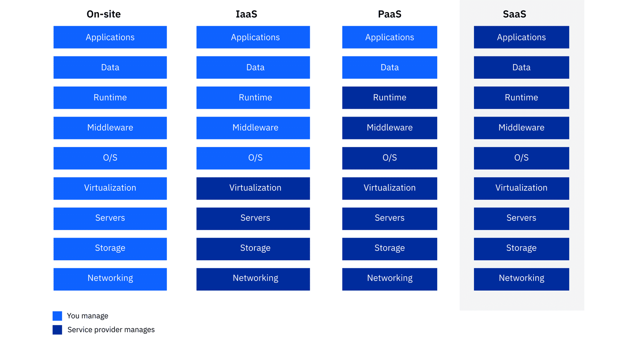

The vendor manages all upgrades and patches to the software, usually invisibly to customers. Typically, the vendor ensures a level of availability, performance, and security as part of a service level agreement (SLA). Customers can add more users and data storage on demand at an additional cost.

Today, anyone who uses a or mobile phone almost certainly uses some form of SaaS. Email, social media, and cloud file storage solutions (such as Dropbox or Box) are examples of SaaS applications people use every day in their personal lives. Popular business or enterprise SaaS solutions include Salesforce (customer relationship management software), HubSpot (marketing software), Trello (workflow management), Slack (collaboration and messaging), and Canva (graphics). Many applications designed originally for the desktop (e.g., Adobe Creative Suite) are now available as SaaS (e.g., Adobe Creative Cloud).

**Benefits of SaaS**

The main benefit of SaaS is that it offloads all infrastructure and application management to the SaaS vendor. All the user has to do is create an account, pay the fee and start using the application. The vendor handles everything else, from maintaining the server hardware and software to managing user access and security, storing, and managing data, implementing upgrades and patches, and more.

1 . The chief advantage of IaaS, PaaS, SaaS, or any 'as a service' solution is economic; a customer can access and scale the IT capabilities it needs for a predictable cost, without the expense and overhead of purchasing and maintaining everything in its own data center.

2 . IaaS means a cloud service provider manages the infrastructure for you—the actual servers, network, virtualization, and data storage—through an internet connection.

3 . PaaS means the hardware and an application-software platform are provided and managed by an outside cloud service provider, but the user handles the apps running on top of the platform and the data the app relies on.

4 . SaaS is a service that delivers a software application—which the cloud service provider manages—to its users.

5 . Outside of Traditional IT infrastructures, IaaS service types give organizations the greatest security and control over their systems; whereas organizations choosing SaaS solutions give up all or most control over day-to-day management to the cloud service provider.